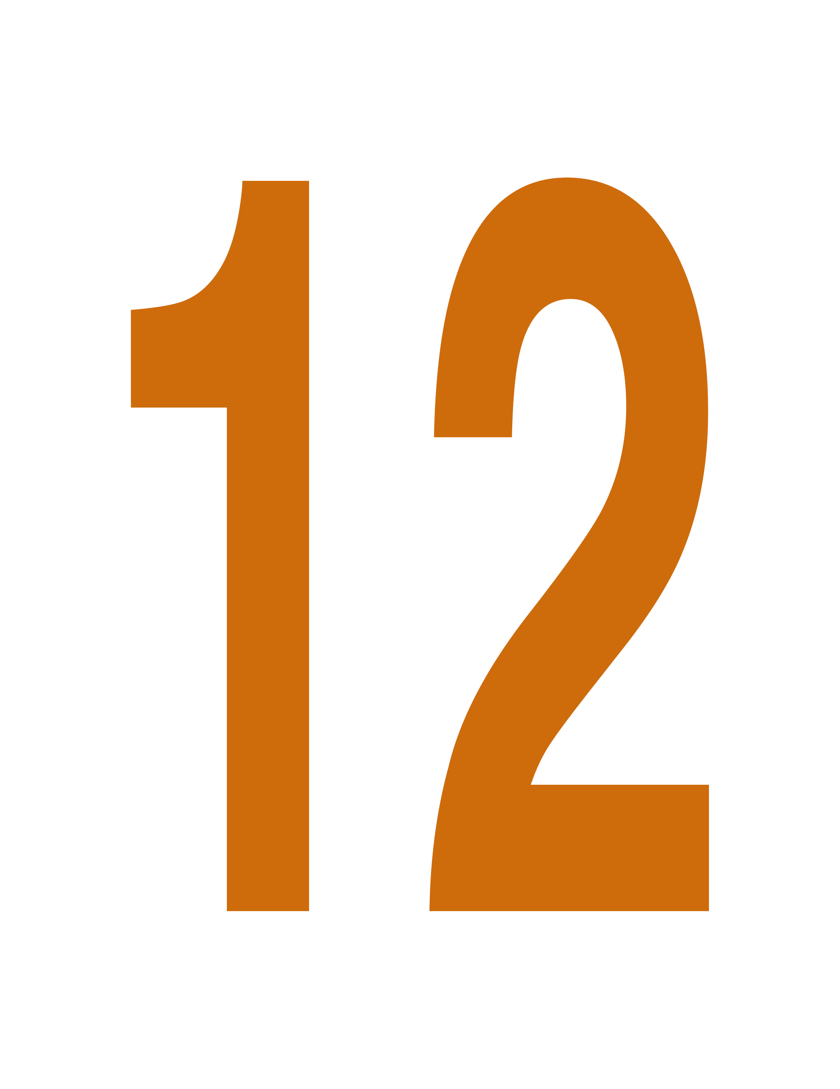

Welsh Poetry Competition - 2020

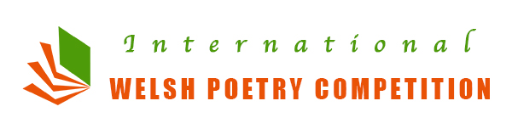

About the Competition
The Welsh Poetry Competition offers a chance for budding writers and published authors from all over the world to compete on an equal footing and be recognised for their work.

After many hugely successful years we are now offering in our 14th international competition:

1st Prize - £500
2nd Prize - £250
3rd Prize - £100

Judge – Sally Spedding

All entries to the competition will be judged anonymously so your creativity will be judged on its own merits. We do not use filter judges!

Further information can be found at our website:

www.welshpoetry.co.uk

Winners will be announced on our website and in the media after the closing date and when all entries have been judged.

Closing date is: Sunday 27th May 2018

About the Judge

 | Sally was born in Porthcawl and originally studied sculpture before winning an international short story competition and finding an agent.  She has published sixteen crime mystery novels, including: Cut To The Bone, The Yellowhammer’s Cradle, Behold a Pale Horse, Death Knell, The Devil’s Garden, Bloodlines, The Nighthawk and Downfall.
Her collection of short stories, Strangers Waiting appeared in 2008. Other stories have been widely published and won several awards including the H E Bates Prize.

Her poetry runs parallel with her fiction, also dealing with the dark hearts of people and places, although humour does occasionally rear its head. Gaudeamus won the Anne Tibble Award and has with others, been widely published.

In 2009, Sally was a finalist for the John Tripp Award for Spoken Poetry. Bristol 2008 was short listed in the Bridport Prize and Den placed first in the Aesthetica Creative Arts Competition. She has won the Welsh Poetry Competition not once but twice! In 2010 with Litzmannstadt 1941 and again in 2012 with She wears green.

She regularly adjudicates national and local writing competitions and often appears at CrimeFest and many book fairs and other literary events.

www.sallyspedding.com

The Entry Form

Name ………...……………………………………………….………………….

Address ………………………………………………………………………….
.………….…………………………………………………………………………
Postcode …………….……… Country ……………………………...……….

Telephone ……………………………………………………………………….

If you’d like to sign up to our GDPR compliant newsletter please write your e-mail below:
…………………………………………………………………………………….

I enclose …..… poems @ £5 each and £ …..... payment by cheque/PO
in GBP made payable to: The Welsh Poetry Competition

I enclose the following poems:

Title 01………………………………………………………………………..

02………………………………………………………………………..

03………………………………………………………………………..

04………………………………………………………………………..

05………………………………………………………………………..
06………………………………………………………………………..

07………………………………………………………………………..

08………………………………………………………………………..

09………………………………………………………………………..
Continue on separate sheet if required

Please attach this form to your poems and payment and forward to:

The Welsh Poetry Competition
9 The Avenue, Pontypridd, CF37 4DF, Wales, UK
Web

Rules of Entry

1. Each poem must be no more than 50 lines in length.
2. Each poem must be typed/clearly written on 1 side of paper.
3. No covering letter or other material should be enclosed.
4. No alterations can be made to a poem once it has been
submitted.
5. The entrant may submit an unlimited number of poems, £5 per
poem (£6 PayPal). We only accept sterling.
6. Cheques and postal orders should be made payable to:
The Welsh Poetry Competition.
7. The poem(s) should be firmly attached to the entry form. The
name of the entrant must not appear on the entry itself.
8. Once entered, poems cannot be withdrawn from the
competition. It is regretted that no entries can be returned, so
keep a copy of your work.
9. All winners will normally be requested to provide a biography
and photograph and take part in any subsequent publicity
surrounding the competition.
10. Acknowledgement of receipt of poems will only be given if a SAE
marked “Acknowledgement” is enclosed.
11. Entries must be in English, not previously published in any
form (including appearing on the Internet).
12. The author must be living.
13. No translations are allowed.
14. Entries can be in any style and on any subject.
15. Entries should not be submitted for publication elsewhere while
the competition is running.
16. Winners will be decided by our judge Sally Spedding. Her
decision is final and no correspondence will be entered into.
17. The organisers reserve the right to change the judge if
circumstances dictate.
18. The competition is open until Sunday 31st May 2020. All entries
must reach us by that date.
19. All winning poems will be announced and published on our
website, may be published elsewhere in the media and will also
appear in a future anthology.
20. Copyright remains with the competitor, but The Welsh Poetry
Competition reserves the right to arrange the first publication
or broadcast of selected poems as it sees fit. Submission of a
poem(s) implies the competitor’s acceptance of the rules.

The closing date is: Sunday 31st May 2020

