

|  |
| --- |
| **Our Judge**    **Mike Jenkins** is an award-winning Welsh poet and author. He is widely published and is much in demand for his lively performances and writing workshops. He has also performed at the Hay Festival, the Aldeburgh Poetry Festival and has read and tutored at Ty Newydd, the National Writers' Centre for Wales.  He has won Wales Book of the Year in 1998 for his collection of short stories ‘Wanting to Belong’. He has also won an Eric Gregory Award from the Society of Authors, The Young Writers Prize from the Welsh Arts Council for ‘Empire of Smoke’ and the John Tripp Award for Spoken Poetry.  Mike is at the forefront of contemporary Welsh writing and is a fellow of the Academi, the Welsh Society for Authors. He is a former editor of Poetry Wales magazine and has co-edited Red Poets for 25 years, an annual magazine of left-wing poetry from Wales and beyond.  Poetry forms the bulk of Mike's published work, though he has also written three novellas for young people and one for adults. His latest book is ‘From Aberfan t Grenfell’ (Cultural Matters) with artist Alan Perry.  Mike is a retired teacher of English and his last job was at Radyr Comprehensive School, Cardiff. He previously taught at Pen-y-dre High School in Merthyr for 20 years.  Mike frequently appears on radio and television and is known among Cardiff City football fans as the club's unofficial poet.  [**www.mikejenkins.net**](http://www.mikejenkins.net) |

**Welsh Poetry Competition - 2019**

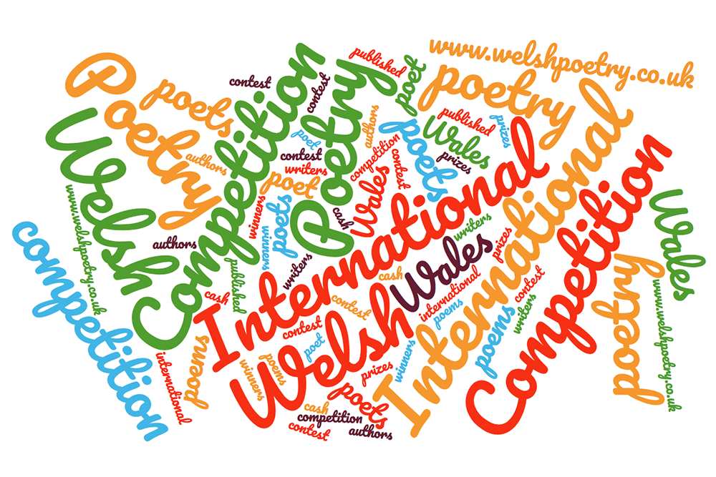

**About the Competition**

The Welsh Poetry Competition offers a chance for budding writers and published authors from all over the world to compete on an equal footing and be recognised for their work.

After twelve successful years we are offering this year:

**1st Prize - £500**

**2nd Prize - £250**

**3rd Prize - £100**

**Judge – Mike Jenkins**

All entries to the competition will be judged anonymously so your creativity will be judged on its own merits. We do not use filter judges!

Further information can be found at our website:

[**www.welshpoetry.co.uk**](http://www.welshpoetry.co.uk)

Winners will be announced on our website and in the media after the closing date and when all entries have been judged.

Closing date is: **Sunday 26th May 2019**

**Rules of Entry**

1. Each poem must be no more than 50 lines in length.

2. Each poem must be typed/clearly written on 1 side of paper.

3. No covering letter or other material should be enclosed.

4. No alterations can be made to a poem once it has been submitted.

5. The entrant may submit an unlimited number of poems, £5 per poem   
 (£6 PayPal). We only accept sterling.

6. Cheques and postal orders should be made payable to:  
 **The Welsh Poetry Competition**.

7. The poem(s) should be firmly attached to the entry form. The name of the   
 entrant must not appear on the entry itself.

8. Once entered, poems cannot be withdrawn from the competition. It is   
 regretted that no entries can be returned, so keep a copy of your work.

9. All winners will normally be requested to provide a biography and   
 photograph and take part in any subsequent publicity surrounding the   
 competition.

10. Acknowledgement of receipt of poems will only be given if a SAE  
 marked “Acknowledgement” is enclosed.

11. Entries must be in English, not previously published in any form   
 (including appearing on the Internet).

12. The author must be living.

13. No translations are allowed.

14. Entries can be in any style and on any subject.

15. Entries should not be submitted for publication elsewhere while the   
 competition is running.

16. Winners will be decided by our judge **Mike Jenkins**. His decision is final and   
 no correspondence will be entered into.

17. The organisers reserve the right to change the judge if circumstances   
 dictate.

18. The competition is open until Sunday 26th May 2019. All entries must reach   
 us by that date.

19. All winning poems will be announced and published on our website, may be   
 published elsewhere in the media and will also appear in a future   
 anthology.

20. Copyright remains with the competitor, but **The Welsh Poetry  
 Competition** reserves the right to arrange the first publication or broadcast   
 of selected poems as it sees fit. Submission of a poem(s) implies the   
 competitor’s acceptance of the rules.

**The closing date is: Sunday 26th May 2019**

**The Entry Form**

Name ………...……………………………………………….……………………………………………..…

Address …………………………………………………………………………………………………..……  
  
.………….………………………………………………………………………………………………..……….

Postcode …………….…………………… Country ……………………………...……………..…….

Telephone …………………………………………………………………………………….……………..

If you’d like to sign up to our GDPR compliant newsletter please write your  
e-mail below:   
  
……………………………………………………………………………………………………………………

I enclose ……...… poems @ **£5** each and £ ……...... payment by cheque/PO in GBP made payable to: **The Welsh Poetry Competition**

I enclose the following poems:

Title 01………………………………………………………………………………………..……...

02…………………………………………………………………………………..……….…..

03………………………………………………………………………………..……………...

04…………………………………………………………………………….………………...

05……………………………………………………………………………………….….…..

06……………………………………………………………………………………….….…..

*Continue on separate sheet if required*

Please send this form, your poems and payment to:

**The Welsh Poetry Competition  
9 The Avenue, Pontypridd, CF37 4DF, Wales, UK**

*Online*